EASY

1.A shop will give discount of 10% if the cost of purchased quantity is more than 1000.Ask user for quantity. Suppose, one unit will cost 100.Judge and print total cost for user.

2. A company decided to give bonus of 5% to employee if his/her year of service is more than 5 years. Ask user for their salary and year of service and print the net bonus amount.

3.Write a program to print absolute value of a number entered by user. E.g.- INPUT: 5 OUTPUT: 5 INPUT: -5 OUTPUT: 5

4. WAP to admit only kids whose age is less than 14 and greater than 8 or whose height is more than 120cm and less than 150cm to a particular ride in an amusement park.

5. Accept three positive integers from the user, and check if they form sides of a right angled triangle

CHALLENGE

1. Accept a string and return a new string formed using the middle three characters. IF the input string is of even length, make a string of odd length as below

* Add a period . at the end if it is not there
* Otherwise remove the period . from the end

1. 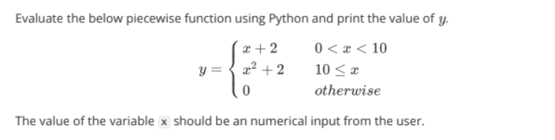

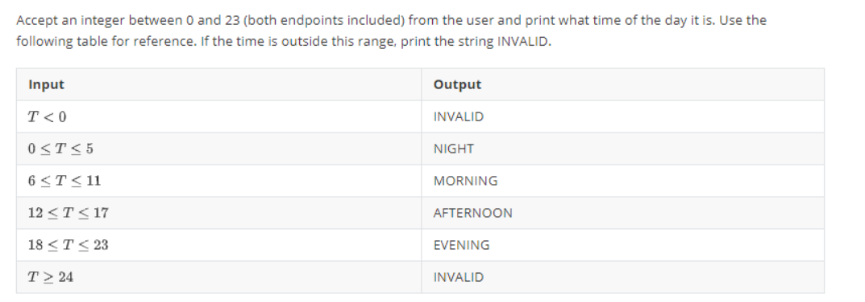

1. 